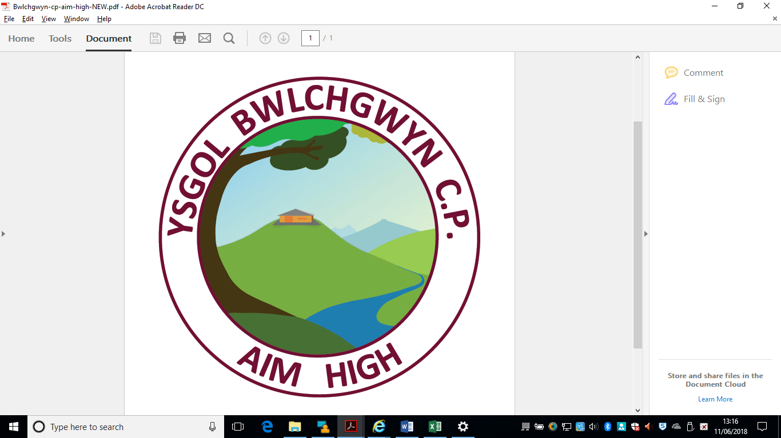
Bwlchgwyn School
Brymbo Road
Bwlchgwyn
LL11 5UA
Tel:01978-269930
Ysgol Bwlchgwyn
Ffordd Brymbo
Bwlchgwyn
LL11 5UA
Ffon:01978-269930

e-mail/e-bost:mailbox@bwlchgwyn-pri.wrexham.sch.uk
Mr. Dylan Williams: Headteacher
YSGOL BWLCHGWYN C.P.

APPLICATION FOR PUPIL LEAVE OF ABSENCE FROM SCHOOL

Any applications for absence in term time will be considered on an individual basis as parents do not have the automatic right to withdraw their children from school for holidays. School cannot agree to a child missing more than 10 days in any school year. If the school does not grant leave of absence and the child is still absent from school, this will be recorded as an unauthorised absence.
The Headteacher will consider the following points before authorising any absence:
- The child’s previous attendance history
- The age of the child/ren
- The child’s stage of education
- The time of year (Pupil Assessments)
- The nature of the trip
- Absence already taken
- Where the parents are restricted in terms of leave from their employer

Full name of child
Class |  | Date(s) of  Absence
Total School Days Child Will Be Absent
Reason for application

Signature of
Parent/Carer

Date

For School Use Only – Copy to be returned to parent/carer
Request seen by Headteacher | Yes / No | Total School Days Absent -Academic Year to Date
Current Attendance Year to Date |  | Total No. Holidays Agreed - Academic Year to Date
Discuss held with Parent/Carer? | Yes / No | Approved | Yes / No
Signed (Headteacher)

SIMS UPDATED |  | CONFIRMATION TO PARENT

